Thank you for taking your time to have a look at my demo project – **Eshop**.

Eshop is built as an online shopping platform(like taobao) . And I focused on the development of the **backend** **system** for this online shopping system.

Below are the current functional and technical framework of backend system of Eshop.

Also, I will continuous improving it, including the function and the framework.

Thanks for you reading

1. **Functional Outline**
   1. **Functional Structure**

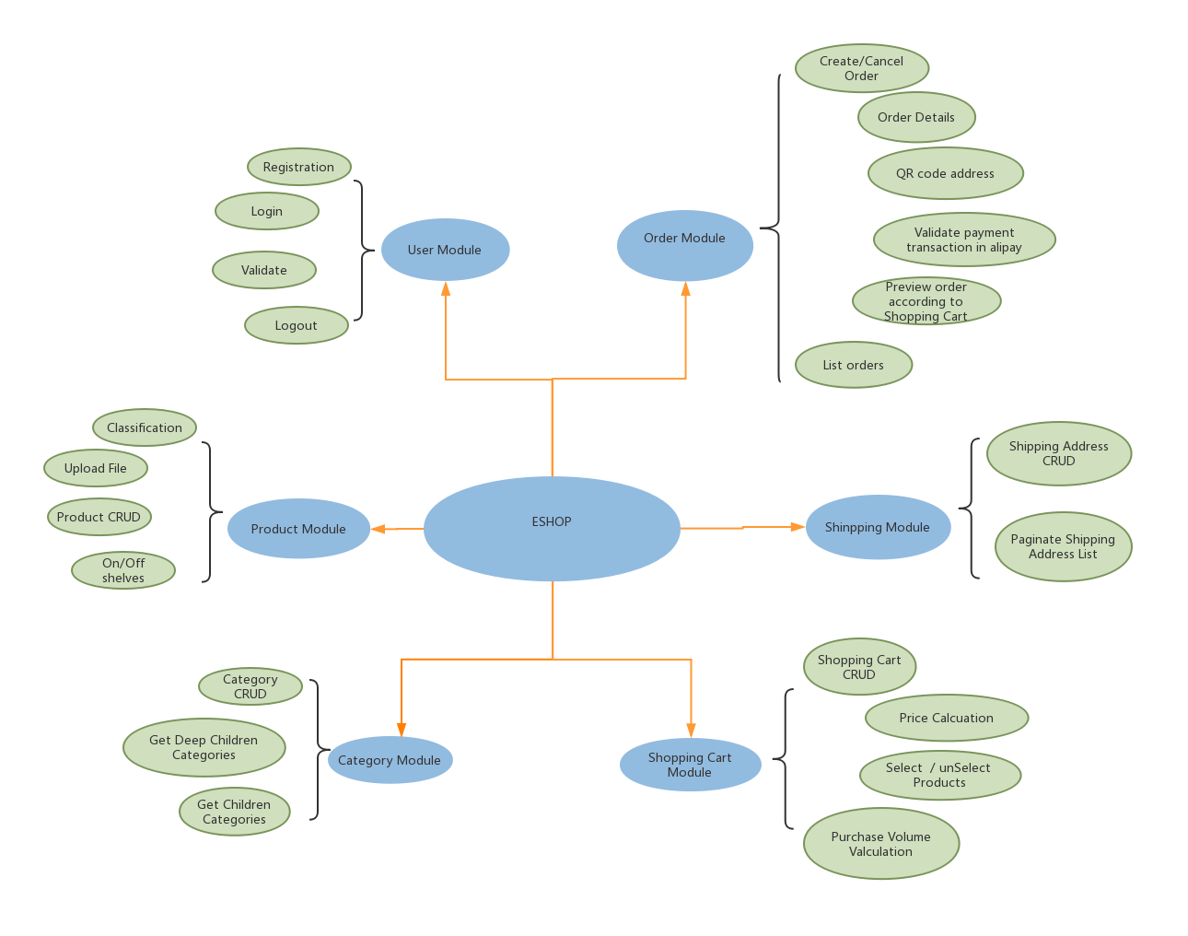

* 1. **Interfaces for Function Modules**

Interfaces for each functional module are as below.



Details:

User Module



Product Module



Category Module



Shinpping Module



Shopping Cart Module



Order Module



1. **System Framework**
   1. **Clustered System Framework**

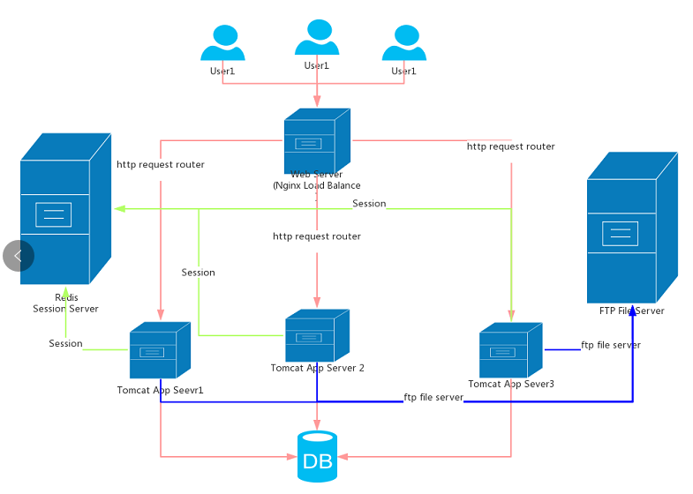

Description:

1. Project in my PC could be deployed to multiple Tomcat Servers and healthy running, and using Nginx to load balance, route requests to different tomcats with Load Balancing Strategy(like weighting strategy)
2. User info for accessing authentication also are cached in Redis to hept to implement SSO(single sign on) in this clustered system.
3. Uploaded files are saved to ftp server for FE to retrieve.
4. This backend system integrates traditional SSM framework (Spring + SpringMVC + MyBatis) and Oracle database to handle business request from FE and then response.

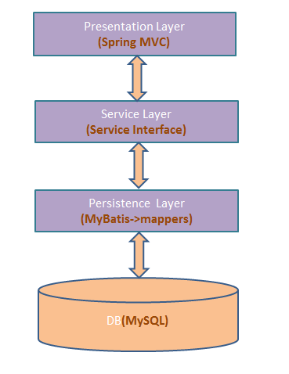

* 1. **Technical key point in current project**

1. To implement SSO(Single Sign On) in this clustered system, add a cookie as token(tokenName=” eshop_login_token”) when user first-send login request, then bind the token and user data to redis , and return this cookie to User browser for next validation of user’s next access.

For detailed code, please refer to below programs:

|  |  |
| --- | --- |
| Class | Method |
| com.eshop.controller.UserController | public ServerResponse<User> login(String username, String password, HttpSession session, HttpServletResponse httpServletResponse) |
| com.eshop.utilities.RedisPoolUtil | public static String setEx(String key, int exTime, String value) |
| com.eshop.utilities.CookieUtil | public static void writeLoginToken(HttpServletResponse response, String token)  public static String readLoginToken(HttpServletRequest request) |
| CookieUtil |  |

1. Using SpringMVC global exception to wrap runtime exception

Please refer to details in com.eshop.common.ExceptionResolver.java

1. Using SpringMVC Interceptor to intercept the request with “/manage/**" format, to do validation of user authority before XXXManageController handle the user request.

Please refer to details in

com.eshop.common.Const. AuthorityInterceptor.java

1. Payment function with Alipay, need to validate the payment transaction order in Alipay to confirm if the payment for order has been done

Please refer to details in

com.eshop.controller.portal.OrderController.java

Method:

public Object alipayCallback(HttpServletRequest request) {}

* 1. **Project Evolution Plan**

Next Version will be advanced to integrate spring Boot and spring data to simplify the configuration files and refactor interface with REST style.